 | Green Line 1 | Unit 1, Station 1 | KV 4
KV 4 Find the rule: The verb to be

1 Find the new forms
Read what Karam and Ryan say. Underline the short forms of to be.

Karam: Hi Ryan. How are you?
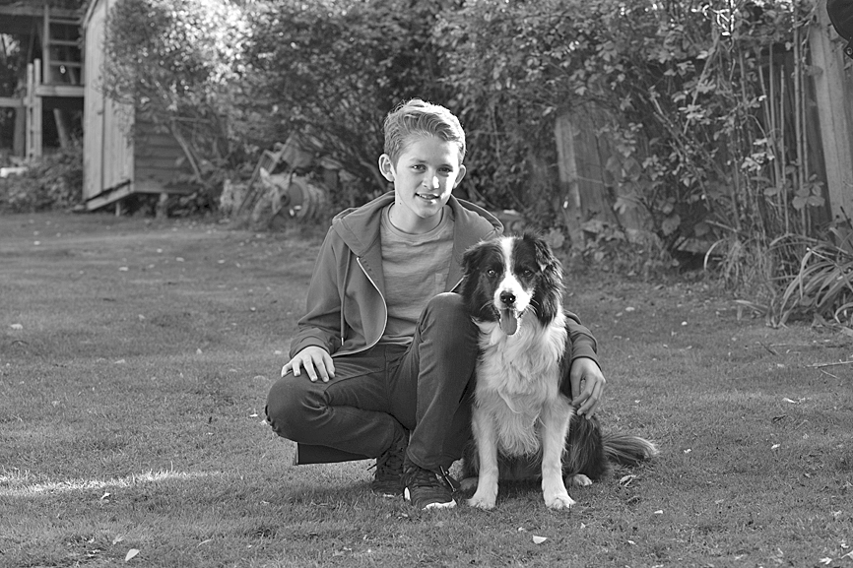

Ryan: I’m fine, thanks.
Karam: I can’t see Ruby.
Ryan: She’s with Lily. They’re at Greenwich Market.
Karam: And how are you, Sherlock?
Ryan: He’s fine! We’re in the park, and he likes the park.
It’s great here.
Karam: You’re a good dog, Sherlock!

2 Find the rule
- Look at the text in a) again. Complete the grid with the short forms of to be.

long forms | short forms |  | long forms | short forms
I am |  |  | we are
you are |  |  | you are
he is |  |  | they are
she is
it is

- Ruby calls Ryan. Complete the sentences with short forms of to be.

Ruby: Hi! I with Lily. We at Greenwich Market. It great!
Ryan: I in the park.
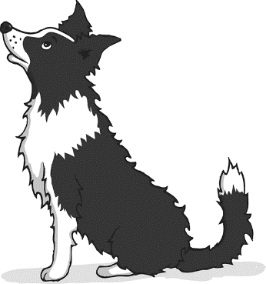
Ruby: And Karam?
Ryan: He here too, and Sherlock. They fine.
Karam: Hellooooooo!
Ruby: Ha ha! You funny, Karam.

3 Check the grammar
Look at G2a) on p. 156 in the Grammar section.

