 | Green Line 1 | Unit 1, Station 3 | KV 8
KV 8 Take a tour of TTS!

a) Write the names: Rose, Jason, Mia.

 |  | 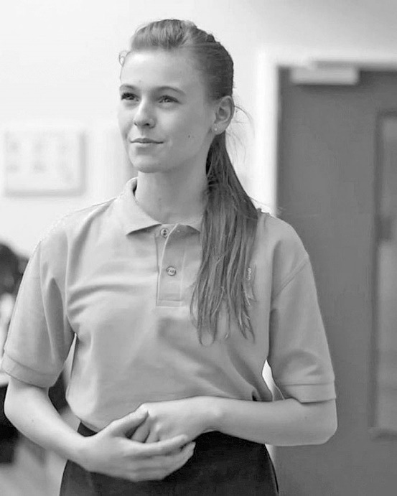 |  | 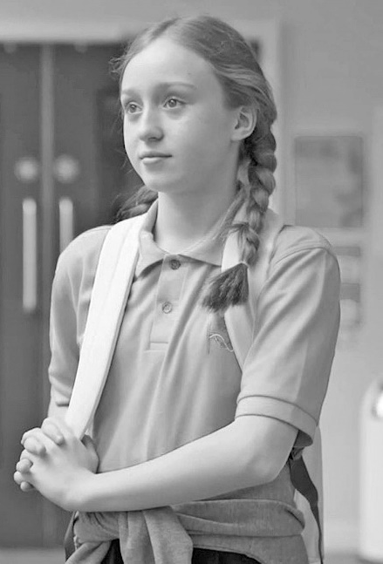

b) Put the places in the order Jason visits them. Write the numbers 1−5. There’s one place you don’t need.
art room
cafeteria
library
classroom
reception area
sports ground

c) Are these statements true or false? Tick the correct answer.

 | true | false
Jason lives in Greenwich.
He has a video channel¹.
Mia can’t do homework in the library.
Students can eat in the library.
Art is Rose’s favourite subject².
Her pictures aren’t on the art room walls.
All the students at TTS have lunch together.
Mia and Rose like pizza.
Rose’s favourite sport isn’t football.
Jason plays table tennis³ after the video.

1 video channel Videokanal 2 subject (Schul-)Fach 3 table tennis Tischtennis

