 | Green Line 1 | Unit 1, Story | KV 9
KV 9 They’re all crazy!

a) Read the story on p. 30 again. Tick the correct answer. For number 8 write a question for your partner.

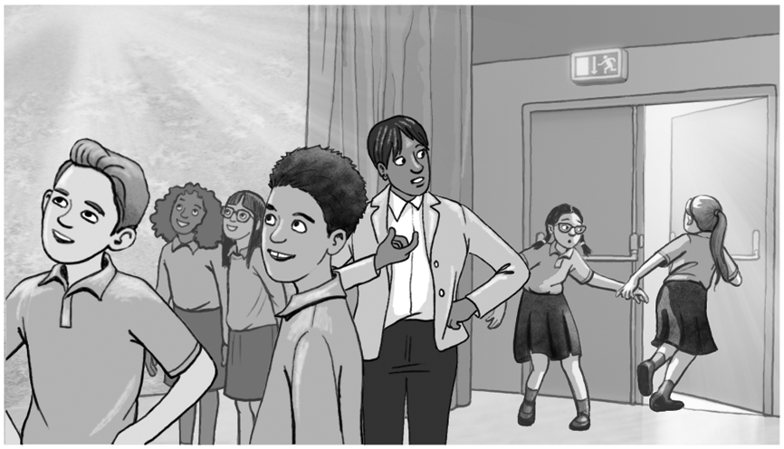

1. Where are Mrs Wilson and the students?  a) They’re in the assembly hall.  b) They’re in a school musical show.  c) They’re in their classroom.  3. What’s the problem?  a) There are cool pictures.  b) Ruby’s hair is a mess.  c) The cupboard is too big.  5. He can‘t …  - go to the sports ground.  - show his football skills.  - .play football in the gym.  7. The drinks are …  - on Ryan’s uniform.  - on the table.  - in Ryan’s face. | 2. Where are Ruby and Lily?  a) They’re with the others on the tour.  b) They’re in the library.  c) They’re in the art room.  4. Karam is …  a) the best student.  b) the best boy in his football team.  c) the best singer in his class.  6. Ryan is …  - happy.  - bored.  - .angry.  8.  a)  b)  c)

b) Choose one task.

1. Get into groups of 3−4 and choose one of the scenes. What voices match the characters’ feelings? Act the scene in your group. Then swap roles.

2. Mrs Wilson and the students are in the library. What can happen there? Draw a funny scene with Ryan, Ruby, Lily or Karam. Write speech bubbles for it.

3. Write about a room in your school. What are the rules? What can you do there? What can’t you do?

