I Zahlen und Größen | 4 Grundrechenarten

Platzhalter

|  |  |  |  |
| --- | --- | --- | --- |
| Man bestimmt Platzhalter in Additions- und  Subtraktionsaufgaben, indem man die Umkehraufgabe löst.  1 Bestimme den Platzhalter.  a) 11 + = 15 b) 5 + = 13  c) + 12 = 19 d) 9 – = 2  e) 26 – = 21 f) – 3 = 18  g) + 73 = 95 h) 69 – = 26  i) 25 + = 57 j) – 26 = 32 |  | Beispiel  5 +  = 9  9 – 5 =  = 4  also 5 + **4** = 9 | 17 –  = 12  17 – 12 =  = 5  also 17 – **5** = 12 |

2 Bestimme den Platzhalter.

a) 3 + 2 + = 10 b) 11 + 5 + = 19 c) 20 – 10 – = 6 d) 20 – 5 – = 9

3 Ergänze die fehlenden Zahlen.

|  |  |  |  |  |  |  |  |  |  |  |  |  |  |  |  |  |  |  |  |  |  |  |  |  |  |  |  |  |  |  |  |  |  |  |
| --- | --- | --- | --- | --- | --- | --- | --- | --- | --- | --- | --- | --- | --- | --- | --- | --- | --- | --- | --- | --- | --- | --- | --- | --- | --- | --- | --- | --- | --- | --- | --- | --- | --- | --- |
|  |  |  |  |  |  |  |  |  |  |  |  |  |  |  |  |  |  |  |  |  |  |  |  |  |  |  |  |  |  |  |  |  |  |  |
|  |  | Z | E |  |  |  |  |  |  | Z | E |  |  |  |  |  |  |  | Z | **E** |  |  |  |  |  |  |  | Z | E |  |  |  |  |  |
|  |  | 4 | 2 |  |  |  |  |  |  | 2 | 4 |  |  |  |  |  |  |  | 6 | 3 |  |  |  |  |  |  |  | 7 | 2 |  |  |  |  |  |
|  | + |  |  |  |  |  |  |  | + |  |  |  |  |  |  |  |  | + |  |  |  |  |  |  |  |  | + |  |  |  |  |  |  |  |
|  |  | 4 | 8 |  |  |  |  |  |  | 3 | 5 |  |  |  |  |  |  |  | 6 | 9 |  |  |  |  |  |  |  | 9 | 9 |  |  |  |  |  |
|  |  |  |  |  |  |  |  |  |  |  |  |  |  |  |  |  |  |  |  |  |  |  |  |  |  |  |  |  |  |  |  |  |  |  |

4 Trage die fehlenden Zahlen in die Rechenmauer ein. Addiere dazu die Zahlen.

|  |  |  |  |  |  |  |  |  |  |  |  |  |  |  |  |  |  |  |  |  |  |  |  |  |  |  |  |  |  |  |  |  |  |  |  |  |  |  |  |  |  |  |  |  |  |  |  |  |  |  |  |  |  |  |  |  |  |  |  |  |  |  |  |  |  |  |  |  |  |  |  |  |  |  |  |  |  |  |  |  |  |  |  |  |  |  |  |  |  |  |  |  |  |  |  |  |  |  |  |  |  |  |
| --- | --- | --- | --- | --- | --- | --- | --- | --- | --- | --- | --- | --- | --- | --- | --- | --- | --- | --- | --- | --- | --- | --- | --- | --- | --- | --- | --- | --- | --- | --- | --- | --- | --- | --- | --- | --- | --- | --- | --- | --- | --- | --- | --- | --- | --- | --- | --- | --- | --- | --- | --- | --- | --- | --- | --- | --- | --- | --- | --- | --- | --- | --- | --- | --- | --- | --- | --- | --- | --- | --- | --- | --- | --- | --- | --- | --- | --- | --- | --- | --- | --- | --- | --- | --- | --- | --- | --- | --- | --- | --- | --- | --- | --- | --- | --- | --- | --- | --- | --- | --- | --- | --- |
| |  |  |  |  |  |  |  |  |  |  | | --- | --- | --- | --- | --- | --- | --- | --- | --- | --- | |  |  |  |  | 81 | |  |  |  |  | |  |  |  |  | |  | |  |  |  | |  |  |  | | 15 | |  | |  |  | |  | 14 | |  | | 11 | |  | |  | |  | | 3 | | 1 | |  | | 12 | | |  | |  |  |  |  |  |  |  |  |  |  | | --- | --- | --- | --- | --- | --- | --- | --- | --- | --- | |  |  |  |  | 88 | |  |  |  |  | |  |  |  |  | |  | |  |  |  | |  |  |  | | 8 | |  | |  |  | |  |  | |  | |  | | 49 | |  | | 14 | | 1 | | 3 | | 1 | |  | | |

5 Finde die Regel und vervollständige die Zahlenreihen.

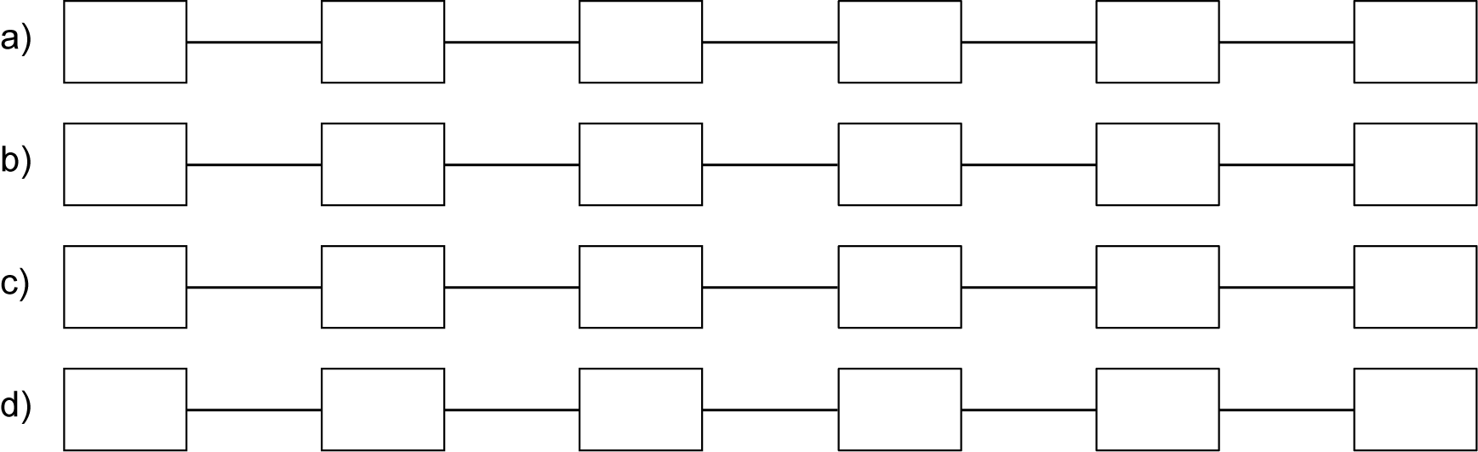

I

II

III

1

2

4

16

3

6

9

70

63

49

I Zahlen und Größen | 4 Grundrechenarten

Platzhalter – Lösungen

1 a) 4 b) 8 c) 7 d) 7   
e) 5 f) 21 g) 22 h) 43   
i) 32 j) 58

2 a) 5 b) 3 c) 4 d) 6

3 6; 11; 6; 27

4

|  |  |  |  |  |  |  |  |  |  |
| --- | --- | --- | --- | --- | --- | --- | --- | --- | --- |
|  |  |  |  | 81 | |  |  |  |  |
|  |  |  | **33** | | **48** | |  |  |  |
|  |  | **18** | | 15 | | **33** | |  |  |
|  | 14 | | **4** | | 11 | | **22** | |  |
| **11** | | 3 | | 1 | | **10** | | 12 | |

|  |  |  |  |  |  |  |  |  |  |
| --- | --- | --- | --- | --- | --- | --- | --- | --- | --- |
|  |  |  |  | 88 | |  |  |  |  |
|  |  |  | **27** | | **61** | |  |  |  |
|  |  | **19** | | 8 | | **53** | |  |  |
|  | **15** | | **4** | | **4** | | 49 | |  |
| 14 | | 1 | | 3 | | 1 | | **48** | |

5

|  |
| --- |
| ../742414_Schmuckelemente/SE96742414_K01_I07_001_Loes.tif |