I Zahlen und Größen | 5 Rechnen mit Geld

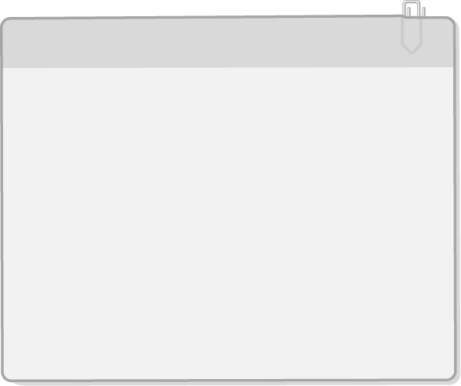

|  |  |
| --- | --- |
| Geld  1 a) Lies die eingetragenen Werte in € ab. | Beispiel    100 ct = 1 €  1_Cent1_Euro |
| ../742414_Schmuckelemente/SE96742414_K06_I22_004.tif |
| b) Lies die eingetragenen Werte ab. Schreibe sie in € und ct in die  Tabelle. |
| ../742414_Schmuckelemente/SE96742414_K06_I22_005.tif | | |

|  |  |  |  |  |
| --- | --- | --- | --- | --- |
|  | A | B | C | D |
| in Euro | 0,05 € |  |  |  |
| in Cent |  |  |  |  |

2 a) Kennzeichne die Geldwerte auf dem Zahlenstrahl.

|  |  |  |  |  |  |
| --- | --- | --- | --- | --- | --- |
| A = 5 ct | B = 30 ct | C = 50 ct | D = 75 ct | E = 85 ct | F = 120 ct |
| ../742414_Schmuckelemente/SE96742414_K06_I22_006.tif | | | | | |

b) Kennzeichne die Geldwerte auf dem Zahlenstrahl.

|  |  |  |  |  |  |
| --- | --- | --- | --- | --- | --- |
| A = 15 ct | B = 85 ct | C = 0,50 € | D = 1,70 € | E = 1 € | F = 1,90 € |
| ../742414_Schmuckelemente/SE96742414_K06_I22_007.tif | | | | | |

3 a) Addiere die Geldwerte. Schreibe an die Pfeile passende Aufgaben.

|  |  |
| --- | --- |
| Beispiel: | ../742414_Schmuckelemente/SE96742414_K06_I22_008.tif |

|  |
| --- |
| ../742414_Schmuckelemente/SE96742414_K06_I22_009.tif |

b) Subtrahiere die Geldwerte. Schreibe an die Pfeile passende Aufgaben.

|  |
| --- |
| ../742414_Schmuckelemente/SE96742414_K06_I22_010.tif |

|  |  |  |  |  |  |  |  |  |  |  |  |  |  |  |  |  |  |  |  |  |  |  |  |  |  |  |  |  |  |  |  |  |  |  |  |  |  |  |  |  |  |  |  |  |  |  |  |  |  |  |  |  |  |  |  |  |  |  |  |  |  |  |  |  |  |  |  |  |  |  |  |  |  |  |  |  |  |  |  |  |  |  |  |  |  |  |  |  |  |  |  |  |  |  |  |  |  |  |  |  |  |  |  |  |  |  |  |  |  |  |  |  |  |  |  |  |  |  |  |  |  |  |
| --- | --- | --- | --- | --- | --- | --- | --- | --- | --- | --- | --- | --- | --- | --- | --- | --- | --- | --- | --- | --- | --- | --- | --- | --- | --- | --- | --- | --- | --- | --- | --- | --- | --- | --- | --- | --- | --- | --- | --- | --- | --- | --- | --- | --- | --- | --- | --- | --- | --- | --- | --- | --- | --- | --- | --- | --- | --- | --- | --- | --- | --- | --- | --- | --- | --- | --- | --- | --- | --- | --- | --- | --- | --- | --- | --- | --- | --- | --- | --- | --- | --- | --- | --- | --- | --- | --- | --- | --- | --- | --- | --- | --- | --- | --- | --- | --- | --- | --- | --- | --- | --- | --- | --- | --- | --- | --- | --- | --- | --- | --- | --- | --- | --- | --- | --- | --- | --- | --- | --- | --- | --- | --- |
| 4 Klaus kauft ein. Wie viel muss er bezahlen?  ../742414_Schmuckelemente/SE89742414_G_K06_I22_011.tif |  | |  |  |  |  |  |  |  |  |  |  |  |  |  |  |  |  |  |  |  |  | | --- | --- | --- | --- | --- | --- | --- | --- | --- | --- | --- | --- | --- | --- | --- | --- | --- | --- | --- | --- | |  |  |  |  |  |  |  |  |  |  |  |  |  |  |  |  |  |  |  |  | |  |  |  |  |  |  |  |  |  |  |  |  |  |  |  |  |  |  |  |  | |  |  |  |  |  |  |  |  |  |  |  |  |  |  |  |  |  |  |  |  | |  |  |  |  |  |  |  |  |  |  |  |  |  |  |  |  |  |  |  |  | |  |  |  |  |  |  |  |  |  |  |  |  |  |  |  |  |  |  |  |  | |  |  |  |  |  |  |  |  |  |  |  |  |  |  |  |  |  |  |  |  | |

I Zahlen und Größen | 5 Rechnen mit Geld

Geld – Lösungen

1 a)

|  |
| --- |
| SE96742414_K06_I22_004_Loes |

b)

|  |  |  |  |  |
| --- | --- | --- | --- | --- |
|  | A | B | C | D |
| in Euro | 0,05 € | 0,20 € | 0,40 € | 0,70 € |
| in Cent | 5 ct | 20 ct | 40 ct | 70 ct |

2 a)

|  |
| --- |
| ../742414_Schmuckelemente/SE96742414_K06_I22_006_Loes.tif |

b)

|  |
| --- |
| ../742414_Schmuckelemente/SE96742414_K06_I22_007_Loes.tif |

3 a)

|  |
| --- |
| SE96742414_K06_I22_009_Loes |

b)

|  |
| --- |
| ../742414_Schmuckelemente/SE96742414_K06_I22_010_Loes.tif |

4 4,90 € + 1,30 € + 1,40 € = 7,60 €