|  |  |  |  |  |  |
| --- | --- | --- | --- | --- | --- |
|  | I Zahlen und Größen, 7 Rechnen mit Gewicht |  |  |  |  |
|  |  | | | | |

Trainingsblatt



1 Es ist $35 kg :50=35 000 g :50=700 g$. Rechne ebenso.

a) $72 g :60$ b) $96 t :120$ c) $1 g :100$

=  =  =

d) $18 kg 4 g :4$ e) $6 t 24 kg :500$ f) $100 kg 100 g :1001$

=  =  =



2 Berechne.

a) $75 kg 120 g+14 kg 72 g$ b) $55 g 123 mg-1897 mg$ c) $7 g 34 mg∙3$

=  =  =

d) $19 kg 8 g :4$ e) $17 kg+1098 g-7 kg 45 g$ f) $8∙12 t 5 kg$

=  =  =



3 Auf einem Lastwagen, der höchstens mit 10 t beladen werden darf, stehen bereits 9 Kisten mit je 480 kg. Wie viele Kisten von 210 kg dürfen noch zugeladen werden?



4 Ein Würfel wiegt 345 g. Wie schwer ist eines der Päckchen in der letzten Waage?

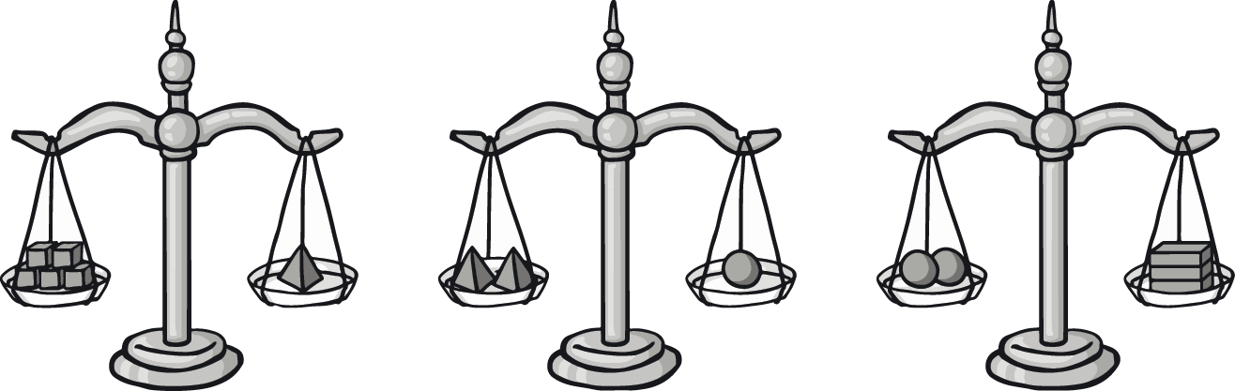

|  |  |  |  |  |  |  |  |  |  |  |  |  |  |  |  |  |  |  |  |  |  |  |  |  |  |  |  |  |  |  |  |  |  |  |
| --- | --- | --- | --- | --- | --- | --- | --- | --- | --- | --- | --- | --- | --- | --- | --- | --- | --- | --- | --- | --- | --- | --- | --- | --- | --- | --- | --- | --- | --- | --- | --- | --- | --- | --- |
|  |  |  |  |  |  |  |  |  |  |  |  |  |  |  |  |  |  |  |  |  |  |  |  |  |  |  |  |  |  |  |  |  |  |  |
|  |  |  |  |  |  |  |  |  |  |  |  |  |  |  |  |  |  |  |  |  |  |  |  |  |  |  |  |  |  |  |  |  |  |  |
|  |  |  |  |  |  |  |  |  |  |  |  |  |  |  |  |  |  |  |  |  |  |  |  |  |  |  |  |  |  |  |  |  |  |  |
|  |  |  |  |  |  |  |  |  |  |  |  |  |  |  |  |  |  |  |  |  |  |  |  |  |  |  |  |  |  |  |  |  |  |  |
|  |  |  |  |  |  |  |  |  |  |  |  |  |  |  |  |  |  |  |  |  |  |  |  |  |  |  |  |  |  |  |  |  |  |  |
|  |  |  |  |  |  |  |  |  |  |  |  |  |  |  |  |  |  |  |  |  |  |  |  |  |  |  |  |  |  |  |  |  |  |  |
|  |  |  |  |  |  |  |  |  |  |  |  |  |  |  |  |  |  |  |  |  |  |  |  |  |  |  |  |  |  |  |  |  |  |  |
|  |  |  |  |  |  |  |  |  |  |  |  |  |  |  |  |  |  |  |  |  |  |  |  |  |  |  |  |  |  |  |  |  |  |  |
|  |  |  |  |  |  |  |  |  |  |  |  |  |  |  |  |  |  |  |  |  |  |  |  |  |  |  |  |  |  |  |  |  |  |  |
|  |  |  |  |  |  |  |  |  |  |  |  |  |  |  |  |  |  |  |  |  |  |  |  |  |  |  |  |  |  |  |  |  |  |  |
|  |  |  |  |  |  |  |  |  |  |  |  |  |  |  |  |  |  |  |  |  |  |  |  |  |  |  |  |  |  |  |  |  |  |  |
|  |  |  |  |  |  |  |  |  |  |  |  |  |  |  |  |  |  |  |  |  |  |  |  |  |  |  |  |  |  |  |  |  |  |  |

|  |  |  |  |  |  |
| --- | --- | --- | --- | --- | --- |
|  | I Zahlen und Größen, 7 Rechnen mit Gewicht |  |  | Lösungen |  |
|  |  | | | | |

Trainingsblatt, S 32

1 a) $72 000 mg :60=1200 mg$ b) $96 000 kg :120=800 kg$  
c) $1000 mg :100=10 mg$ d) $18 004 g :4=4501 g$  
e) $6024 kg :500=6 024 000 g :500=12 048 g$ f) $100 100 g :1001=100 g$

2 a) $75 120 g+14 072 g=89 192 g$ b) $55 123 mg-1897 mg=53 226 mg$  
c) $7034 mg·3=21 102 mg$ d) $19 008 g :4=4752 g$  
e) $17 000 g+1098 g-7045 g=11 053 g$ f) $8·12 005 kg=96 040 kg$

3 Es können noch 27 Kisten zugeladen werden.

4 Ein Päckchen wiegt $2300 g=2 kg 300 g$.